<!DOCTYPE html>

<html lang="en">

<head>

    <!-- Required meta tags -->

    <meta charset="utf-8">

    <meta name="viewport" content="width=device-width, initial-scale=1">

    <meta http-equiv="X-UA-Compatible" content="IE=edge">

    <!-- icon CDN -->

    <link rel="stylesheet" href="https://cdnjs.cloudflare.com/ajax/libs/font-awesome/4.7.0/css/font-awesome.css" integrity="sha512-5A8nwdMOWrSz20fDsjczgUidUBR8liPYU+WymTZP1lmY9G6Oc7HlZv156XqnsgNUzTyMefFTcsFH/tnJE/+xBg==" crossorigin="anonymous" referrerpolicy="no-referrer" />

    <!-- Bootstrap CSS -->

    <link href="https://cdn.jsdelivr.net/npm/bootstrap@5.0.2/dist/css/bootstrap.min.css" rel="stylesheet" integrity="sha384-EVSTQN3/azprG1Anm3QDgpJLIm9Nao0Yz1ztcQTwFspd3yD65VohhpuuCOmLASjC" crossorigin="anonymous">

    <!-- Main.css -->

    <link rel="stylesheet" href="css/main.css">

    <title>Host Cloud</title>

    <style>

    </style>

</head>

<body>

    <!-- Navbar -->

    <div class="top" style="padding-bottom: 30px;">

      <nav class="navbar navbar-expand-lg navbar-light bg-transparent px-5">

        <div class="container-fluid">

            <a class="navbar-brand text-white" href="#"> <span class="first-font fw-bolder">HOST</span>  <span class="second-font">CLOUD</span></a>

            <button class="navbar-toggler" type="button" data-bs-toggle="collapse" data-bs-target="#navbarSupportedContent" aria-controls="navbarSupportedContent" aria-expanded="false" aria-label="Toggle navigation">

              <span class="navbar-toggler-icon"></span>

            </button>

          <div class="collapse navbar-collapse justify-content-end pr-5" id="navbarSupportedContent">

            <ul class="navbar-nav mb-2 mb-lg-0">

              <li class="nav-item">

                <a class="nav-link active text-white hover-nav p-4" aria-current="page" href="#">Home</a>

              </li>

              <li class="nav-item">

                <a class="nav-link active text-white hover-nav p-4" aria-current="page" href="#">About</a>

              </li>

              <li class="nav-item">

                <a class="nav-link active text-white hover-nav p-4" aria-current="page" href="#">Our Services</a>

              </li>

              <li class="nav-item">

                <a class="nav-link active text-white hover-nav p-4" aria-current="page" href="#">Contact Us</a>

              </li>

             </ul>

              <form class="d-flex px-5 nav-margin">

                <button class="bg-transparent text-white rounded-0 border-2 border-white mx-3" type="Login">LOGIN IN</button>

              <button class="btn btn-outline-info bg-info text-white rounded-0" type="signin">SIGN IN</button>

            </form>

      </nav>

      <!-- Search Bar -->

      <div class="search">

        <h1 class="text-center fw-bolder text-white">Find Nearby Places & Things</h1>

        <br>

        <div class="search-bar d-flex justify-content-center">

        <input type="search" class="form-control w-50 bg-transparent border-white rounded-0 text-white" placeholder="Enter your domain here" aria-label="Search"

        aria-describedby="search-addon" />

        <button class="btn btn-outline-info bg-info text-white rounded-0 mx-4 px-4" type="signin">Search Now</button>

        </div>

      </div>

      <!-- Filter Section -->

      <div class="check-list d-flex justify-content-center my-5 text-white flex-wrap">

        <div class="form-check form-check-inline px-4">

            <input class="form-check-input" type="checkbox" id="inlineCheckbox1" value="option1">

            <label class="form-check-label" for="inlineCheckbox1"> <span class="fw-bold">.com</span> ($10/yr)</label>

          </div>

          <div class="form-check form-check-inline px-4">

            <input class="form-check-input" type="checkbox" id="inlineCheckbox2" value="option2">

            <label class="form-check-label" for="inlineCheckbox2"><span class="fw-bold">.net</span> ($12/yr)</label>

          </div>

          <div class="form-check form-check-inline px-4">

            <input class="form-check-input" type="checkbox" id="inlineCheckbox2" value="option2">

            <label class="form-check-label" for="inlineCheckbox2"><span class="fw-bold">.org</span> ($8/yr)</label>

          </div>

          <div class="form-check form-check-inline px-4">

            <input class="form-check-input" type="checkbox" id="inlineCheckbox2" value="option2">

            <label class="form-check-label" for="inlineCheckbox2"><span class="fw-bold">.in</span> ($6/yr)</label>

          </div>

      </div>

    </div>

    <!-- Main Area -->

    <main>

        <!-- Heading -->

        <div class="top-main py-5 bg-light">

            <h5 class="text-center">TRUSTED BY 1,250+ HAPPY CUSTOMERS WORLDWIDE</h5>

            <ul class="list-group list-group-horizontal-lg d-flex justify-content-evenly my-5 px-5 ">

                <li class="list-group-item border-0 bg-light"><h2> <i class="fa fa-archive third-font text-gradient" aria-hidden="true"></i> <span class="fw-bolder">LOGOTEXT</span></h2></li>

                <li class="list-group-item border-0 bg-light"><h2> <i class="fa fa-archive third-font text-gradient" aria-hidden="true"></i> <span class="fw-bolder">LOGOTEXT</span></h2></i></li>

                <li class="list-group-item border-0 bg-light"><h2> <i class="fa fa-archive third-font text-gradient" aria-hidden="true"></i> <span class="fw-bolder">LOGOTEXT</span></h2></i></li>

                <li class="list-group-item border-0 bg-light"><h2> <i class="fa fa-archive third-font text-gradient" aria-hidden="true"></i> <span class="fw-bolder">LOGOTEXT</span></h2></i></li>

              </ul>

        </div>

        <!-- Hosting Services -->

        <div class="main-info search mx-5">

            <h6 class="text-info">Hosting Services</h6>

            <h3 class="">Services we provide</h3>

            <p class="text-seconadry">Host Cloud is a professional Bootstrap 4 template by TemplateMo for your hosting company websites. There are 4 HTML pages included in this template. You can feel free to customize anything. Please share this template to your friends.Thank you.</p>

            <br>

            <!-- Cards - 1 -->

            <div class="cloud d-flex flex-wrap justify-content-center">

            <div class="card text-center bg-light border-0 py-5 mx-5 my-3" style="width: 22rem;">

                <div class="card-body">

                    <i class="fa fa-server third-font bg-info p-5 rounded-circle text-white" aria-hidden="true"></i>

                    <br>

                    <br>

                  <h5 class="card-title">10x Light Cloud</h5>

                  <br>

                  <p class="card-text">Some quick example text to build on the card title and make up the bulk of the card's content. by TemplateMo for your hosting company websites. There are 4 HTML pages included in this template.</p>

                </div>

              </div>

             <!-- Cards - 2 -->

              <div class="card text-center bg-light border-0 py-5 mx-5 my-3" style="width: 24rem;">

                <div class="card-body">

                    <i class="fa fa-server third-font bg-info p-5 rounded-circle text-white" aria-hidden="true"></i>

                    <br>

                    <br>

                  <h5 class="card-title">Managed VPS Cloud</h5>

                  <br>

                  <p class="card-text">Some quick example text to build on the card title and make up the bulk of the card's content. by TemplateMo for your hosting company websites. There are 4 HTML pages included in this template.</p>

                </div>

              </div>

                 <!-- Cards - 3 -->

              <div class="card text-center bg-light border-0 py-5 mx-5 my-3" style="width: 22rem;">

                <div class="card-body">

                    <i class="fa fa-server third-font bg-info p-5 rounded-circle text-white" aria-hidden="true"></i>

                    <br>

                    <br>

                  <h5 class="card-title">Fully Dedicated</h5>

                  <br>

                  <p class="card-text">Some quick example text to build on the card title and make up the bulk of the card's content. by TemplateMo for your hosting company websites. There are 4 HTML pages included in this template.</p>

                </div>

              </div>

            </div>

        </div>

        <!-- Hosting Plans -->

        <div class="plans padding-top">

            <h3 class="text-center text-white">Cloud Hosting Plans</h3>

            <br>

            <p class="right-left-margin text-center text-white">Lorem Ipsum is simply dummy text of the printing and typesetting industry. Lorem Ipsum has been the industry's standard dummy text ever since the 1500s, when an unknown printer took a galley of type and scrambled it to make a type specimen book. </p>

            <!-- Cards -->

            <div class="cards-plans d-flex justify-content-center flex-wrap">

                <!-- Card - 1 -->

                <div class="card text-center bg-light border-0 mx-5 my-3 px-4 shadow rounded-0" style="width: 22rem; padding-bottom: 0; padding-top: 30px;">

                    <div class="card-body">

                      <h5 class="card-title">BASIC CLOUD 5X</h5>

                      <br>

                      <div class="price text-white bg-info p-4">

                      <h1 class="" >&dollar; 15.50</h1>

                      <h6>MONTHLY</h6>

                    </div>

                    <br>

                      <p class="card-text"> make up the bulk of the card's content. by TemplateMo for your hosting company websites. There are 4 HTML pages included in this template.</p>

                    <hr>

                    <p class="text-start" ><i class="fa fa-check" aria-hidden="true"></i> 500GB Storage Space</p>

                    <p class="text-start" ><i class="fa fa-check" aria-hidden="true"></i> 3TB Data Transfer</p>

                    <p class="text-start" ><i class="fa fa-check" aria-hidden="true"></i> Basic Managed Panel</p>

                    <p class="text-start" ><i class="fa fa-check" aria-hidden="true"></i> 27/7 Fast Support</p>

                    <p class="text-start" ><i class="fa fa-check" aria-hidden="true"></i> 100 Premium Themes</p>

                    <p class="text-start" ><i class="fa fa-check" aria-hidden="true"></i> Cancel or Upgrade Anytime</p>

                    <button class="btn bg-info text-white rounded-0" type="signin" style="margin-bottom: -44px;">START PLAN</button>

                    </div>

                  </div>

                   <!-- Cards - 2 -->

                <div class="card text-center bg-light border-0 mx-5 my-3 px-4 shadow rounded-0" style="width: 22rem; padding-bottom: 0; padding-top: 30px;">

                    <div class="card-body">

                      <h5 class="card-title">CLOUD VPS 10X</h5>

                      <br>

                      <div class="price text-white gradient p-4">

                      <h1 class="" >&dollar; 30.00</h1>

                      <h6>MONTHLY</h6>

                    </div>

                    <br>

                      <p class="card-text"> make up the bulk of the card's content. by TemplateMo for your hosting company websites. There are 4 HTML pages included in this template.</p>

                    <hr>

                    <p class="text-start" ><i class="fa fa-check" aria-hidden="true"></i> 1TB Cloud Space</p>

                    <p class="text-start" ><i class="fa fa-check" aria-hidden="true"></i> 8TB Data Transfer</p>

                    <p class="text-start" ><i class="fa fa-check" aria-hidden="true"></i> Fully Managed Panel</p>

                    <p class="text-start" ><i class="fa fa-check" aria-hidden="true"></i> 15-minute Quick Support</p>

                    <p class="text-start" ><i class="fa fa-check" aria-hidden="true"></i> Unlimited Web Addons</p>

                    <p class="text-start" ><i class="fa fa-check" aria-hidden="true"></i> Cancel or Upgrade Anytime</p>

                    <button class="btn gradient text-white rounded-0" type="signin" style="margin-bottom: -44px;">SELECT PLAN</button>

                    </div>

                  </div>

                   <!-- Cards - 3 -->

                <div class="card text-center bg-light border-0 mx-5 my-3 px-4 shadow rounded-0" style="width: 22rem; padding-bottom: 0; padding-top: 30px;">

                    <div class="card-body">

                      <h5 class="card-title">ADVANCED CLOUD</h5>

                      <br>

                      <div class="price text-white bg-info p-4">

                      <h1 class="" >&dollar; 73.25</h1>

                      <h6>MONTHLY</h6>

                    </div>

                    <br>

                      <p class="card-text"> make up the bulk of the card's content. by TemplateMo for your hosting company websites. There are 4 HTML pages included in this template.</p>

                    <hr>

                    <p class="text-start" ><i class="fa fa-check" aria-hidden="true"></i> 4TB Cloud Space</p>

                    <p class="text-start" ><i class="fa fa-check" aria-hidden="true"></i> 20TB Data Transfer</p>

                    <p class="text-start" ><i class="fa fa-check" aria-hidden="true"></i> Fully Managed Panel</p>

                    <p class="text-start" ><i class="fa fa-check" aria-hidden="true"></i> 15-minute Quick Support</p>

                    <p class="text-start" ><i class="fa fa-check" aria-hidden="true"></i> Top Notch Web Apps</p>

                    <p class="text-start" ><i class="fa fa-check" aria-hidden="true"></i> Advanced Scalable</p>

                    <button class="btn bg-info text-white rounded-0" type="signin" style="margin-bottom: -44px;">TAKE IT OUT</button>

                    </div>

                  </div>

                </div>

            </div>

        </div>

        <!-- Features -->

        <div class="features search mx-5">

            <h6 class="text-info text-center">Best Quality For you</h6>

            <h3 class="text-center">Cloud Features</h3>

            <br>

            <br>

            <!-- Cards -->

            <div class="row1 d-flex justify-content-center flex-wrap">

                <!-- Cards - 1 Row- 1 -->

                <div class="card text-center bg-light border-0 mx-5 my-2 px-4 shadow rounded-0" style="width: 50rem; padding-bottom: 0; padding-top: 10px;">

                <div class="card-body setting">

                    <h1><i class="fa fa-sliders px-5 third-font text-gradient" aria-hidden="true"></i></h1>

                    <div class="content1">

                  <h5 class="card-title text-start">Load Balanced</h5>

                  <p class="card-text text-start"> make up the bulk of the card's content. by TemplateMo for your hosting company websites. There are 4 HTML pages included in this template.</p>

                </div>

                </div>

                </div>

                <!-- Cards - 2 Row- 1 -->

            <div class="card text-center bg-light border-0 mx-5 my-2 px-4 shadow rounded-0" style="width: 50rem; padding-bottom: 0; padding-top: 10px;">

                <div class="card-body setting">

                    <h1><i class="fa fa-sliders px-5 third-font text-gradient" aria-hidden="true"></i></h1>

                    <div class="content1">

                  <h5 class="card-title text-start">99.9% Uptime Guaranteed</h5>

                  <p class="card-text text-start"> make up the bulk of the card's content. by TemplateMo for your hosting company websites. There are 4 HTML pages included in this template.</p>

                </div>

                </div>

                </div>

        </div>

         <!-- Cards - 1 Row -2 -->

            <div class="row1 d-flex justify-content-center flex-wrap my-4">

            <div class="card text-center bg-light border-0 mx-5 my-2 px-4 shadow rounded-0" style="width: 50rem; padding-bottom: 0; padding-top: 10px;">

                <div class="card-body setting">

                    <h1><i class="fa fa-sliders px-5 third-font text-gradient" aria-hidden="true"></i></h1>

                    <div class="content1">

                  <h5 class="card-title text-start">Top Realiability</h5>

                  <p class="card-text text-start"> make up the bulk of the card's content. by TemplateMo for your hosting company websites. There are 4 HTML pages included in this template.</p>

                </div>

                </div>

                </div>

                <!-- Cards - 2 Row -2 -->

            <div class="card text-center bg-light border-0 mx-5 my-2 px-4 shadow rounded-0" style="width: 50rem; padding-bottom: 0; padding-top: 10px;">

                <div class="card-body setting">

                    <h1><i class="fa fa-sliders px-5 third-font text-gradient" aria-hidden="true"></i></h1>

                    <div class="content1">

                  <h5 class="card-title text-start">High Security</h5>

                  <p class="card-text text-start"> make up the bulk of the card's content. by TemplateMo for your hosting company websites. There are 4 HTML pages included in this template.</p>

                </div>

                </div>

                </div>

        </div>

        <!-- Cards - 1 Row -3 -->

            <div class="row1 d-flex justify-content-center flex-wrap my-4">

            <div class="card text-center bg-light border-0 mx-5 my-2 px-4 shadow rounded-0" style="width: 50rem; padding-bottom: 0; padding-top: 10px;">

                <div class="card-body setting">

                    <h1><i class="fa fa-sliders px-5 third-font text-gradient" aria-hidden="true"></i></h1>

                    <div class="content1">

                  <h5 class="card-title text-start">Quality Hardware</h5>

                  <p class="card-text text-start"> make up the bulk of the card's content. by TemplateMo for your hosting company websites. There are 4 HTML pages included in this template.</p>

                </div>

                </div>

                </div>

                <!-- Cards - 2 Row -3 -->

            <div class="card text-center bg-light border-0 mx-5 my-2 px-4 shadow rounded-0" style="width: 50rem; padding-bottom: 0; padding-top: 10px;">

                <div class="card-body text-center setting">

                    <h1><i class="fa fa-sliders px-5 third-font text-gradient" aria-hidden="true"></i></h1>

                    <div class="content1">

                  <h5 class="card-title text-start">Network Solutions</h5>

                  <p class="card-text text-start"> make up the bulk of the card's content. by TemplateMo for your hosting company websites. There are 4 HTML pages included in this template.</p>

                </div>

                </div>

                </div>

        </div>

    </div>

    </main>

    <!-- Footer -->

    <footer>

        <!-- Extra Information -->

        <div class="top-footer search">

            <h6 class="text-info text-center">Testimonials</h6>

            <h3 class="text-center">What they say about us</h3>

            <h3 class="text-center search text-secondary"><i class="fa fa-quote-right gradient p-4 rounded-circle text-white" aria-hidden="true"></i></h3>

           <br>

            <p class="text-center right-left-margin"><i>Contrary to popular belief, Lorem Ipsum is not simply random text. It has roots in a piece of classical Latin literature from 45 BC, making it over 2000 years old.

                 Richard McClintock, a Latin professor at Hampden-Sydney College in Virginia, looked up one of the more

                 obscure Latin words, consectetur, from a Lorem Ipsum passage, and going through the cites of the word in classical literature, discovered

                  the undoubtable source. Lorem Ipsum comes from sections 1.10.32 and 1.10.33 of "de Finibus Bonorum et Malorum" (The Extremes of Good and Evil) by Cicero,

                   written in 45 BC. This book is a treatise on the theory of ethics</i> </p>

                   <br>

            <h5 class="text-center">Willian Smith</h5>

            <h6 class="text-info text-center">New-Co-Founder</h6>

        </div>

        <!-- Footer Main-->

        <div class="mid-footer search footer-background">

            <div class="d-flex flex-wrap text-white col-9 right-left-margin">

                <div class="p-2 bd-highlight search col-lg-3 px-5"> <h5>About Us</h5>

                    <br>

                    <p class=""> orem Ipsum passage, and going through the cites of the word in classical literature, discovered

                        the undoubtable source. Lorem Ipsum comes from</p>

                </div>

                <div class="p-2 bd-highlight search px-5"><h5>Hosting Plans</h5>

                    <br>

                <ul class="">

                    <li>Basic Could 5X</li>

                    <li>Cloud VPS 10X</li>

                    <li>Advanced Cloud</li>

                    <li>Custom Designs</li>

                    <li>Special Solutions</li>

                </ul>

                </div>

                <div class="p-2 bd-highlight search px-5"><h5> Useful Links </h5>

                    <br>

                    <ul class="">

                        <li>Cloud Hosting Platform</li>

                        <li>Light Speed Zone</li>

                        <li>Content Delivery Network</li>

                        <li>Latest News</li>

                        <li>Customer Support</li>

                    </ul>

                </div>

                <div class="p-2 bd-highlight search px-5"><h5> More Information </h5>

                    <br>

                    <ul class="">

                        <li><b>Phone:</b> 010-020-0560</li>

                        <li><b>Email:</b> mail@company.com</li>

                        <li><b>Support:</b> support@company.com</li>

                        <li><b>Website:</b> www.company.com</li>

                    </ul>

                </div>

              </div>

              <hr class="text-white">

              <div class="footer-last">

                <p class="text-center text-white py-4">Copyright &copy; 2020 Cloud Hosting Company - Designed by Adeeb Shah</p>

            </div>

        </div>

    </footer>

    <!-- Scripts JS -->

<script src="https://cdn.jsdelivr.net/npm/@popperjs/core@2.9.2/dist/umd/popper.min.js" integrity="sha384-IQsoLXl5PILFhosVNubq5LC7Qb9DXgDA9i+tQ8Zj3iwWAwPtgFTxbJ8NT4GN1R8p" crossorigin="anonymous"></script>

<script src="https://cdn.jsdelivr.net/npm/bootstrap@5.0.2/dist/js/bootstrap.min.js" integrity="sha384-cVKIPhGWiC2Al4u+LWgxfKTRIcfu0JTxR+EQDz/bgldoEyl4H0zUF0QKbrJ0EcQF" crossorigin="anonymous"></script>

</body>

</html>

**Main.css –**

.top{

    background:linear-gradient(311deg, rgba(12,57,198,0.8), rgba(95,44,162,0.7), rgba(126,7,172,0.8)), url(background.jpg);

    background-size: cover;

    background-repeat: repeat-x;

    height: 100%;

  }

  .first-font{

    font-size: 35px;

}

.second-font{

    font-size: 20px;

}

.third-font{

    font-size: 100px;

}

.fourth-font{

    font-size: 200px;

}

.nav-margin{

    margin-right: 60px;

}

.search{

    margin-top: 120px;

}

.padding-top{

    padding-top: 80px;

}

.search-bar{

    height:50px;

}

.right-left-margin{

    margin-left: 20%;

    margin-right: 20%;

}

.plans{

    background:linear-gradient(311deg, rgba(12,57,198,0.8), rgba(95,44,162,0.7), rgba(126,7,172,0.8)), url(background1.jpg);

    background-size: cover;

    height: 500px;

}

.footer-background{

    background:linear-gradient(311deg, rgba(12,57,198,0.8), rgba(95,44,162,0.7), rgba(126,7,172,0.8)), url(background2.jpg);

    background-size: cover;

    height: 100%;

  }

.gradient{

    background: rgb(12,57,198);

    background: linear-gradient(311deg, rgba(12,57,198,1) 0%, rgba(95,44,162,1) 65%, rgba(126,7,172,1) 100%);

}

.text-gradient{

    background: #1D2FCF;

    background: -webkit-linear-gradient(311deg, rgba(12,57,198,1) 0%, rgba(95,44,162,1) 65%, rgba(126,7,172,1) 100%);

    background: -moz-linear-gradient(311deg, rgba(12,57,198,1) 0%, rgba(95,44,162,1) 65%, rgba(126,7,172,1) 100%);

    background: linear-gradient(311deg, rgba(12,57,198,1) 0%, rgba(95,44,162,1) 65%, rgba(126,7,172,1) 100%);

    -webkit-background-clip: text;

    -webkit-text-fill-color: transparent;

}

ul{

    list-style: none;

    margin: 0;

    padding: 0;

    line-height: 35px;

}

.setting{

    display: flex;

}

.features{

    margin-top: 530px;

}

/* Media Qurey */

@media (max-width:1360px){

    .features{

        margin-top: 1250px;

    }

}

@media (max-width:842px){

    .features{

        margin-top: 2000px;

    }

    .setting{

        display: block;

    }

}

@media (max-width:372px){

    .features{

        margin-top: 2200px;

    }

}

**Output-**

**Desktop –**

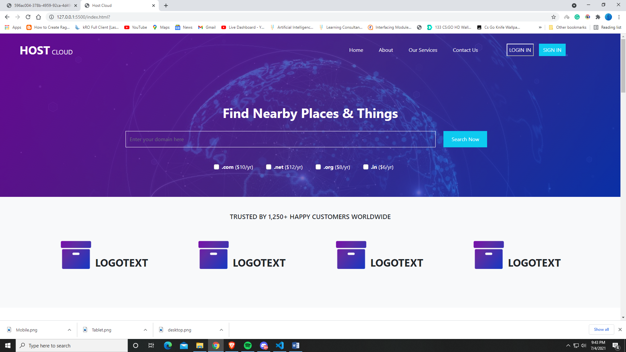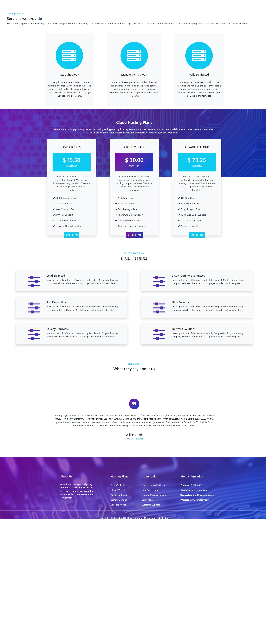

**Tablet**

**–**

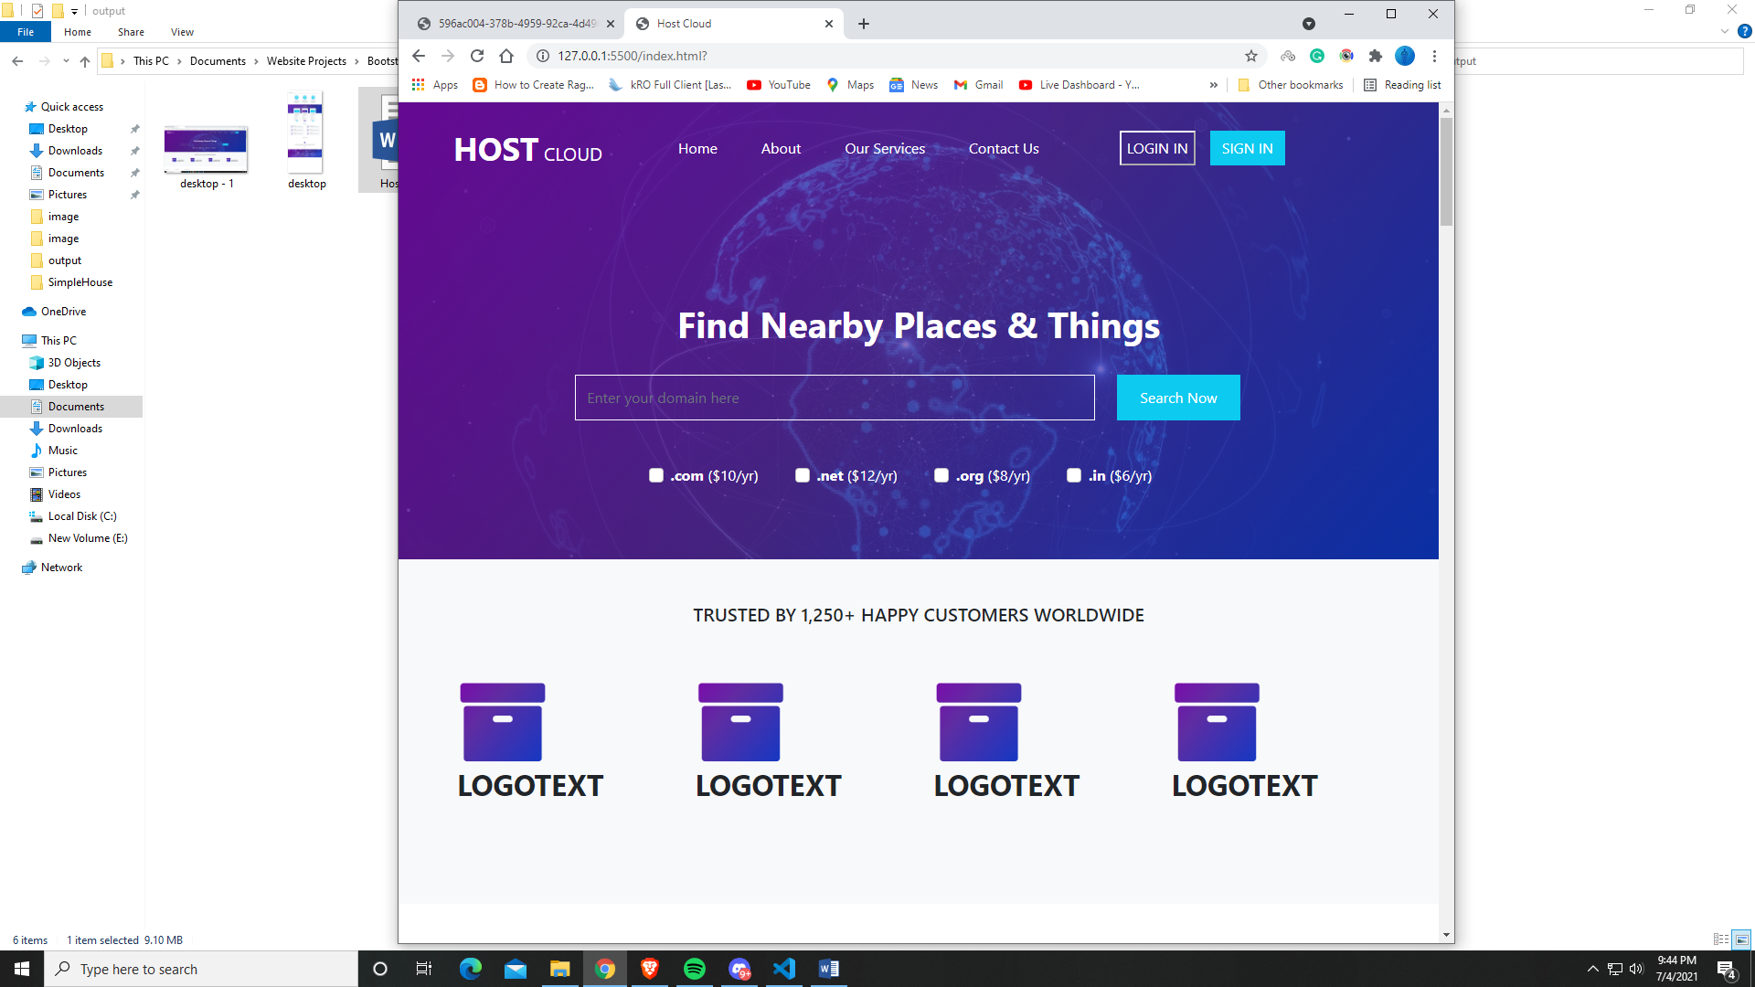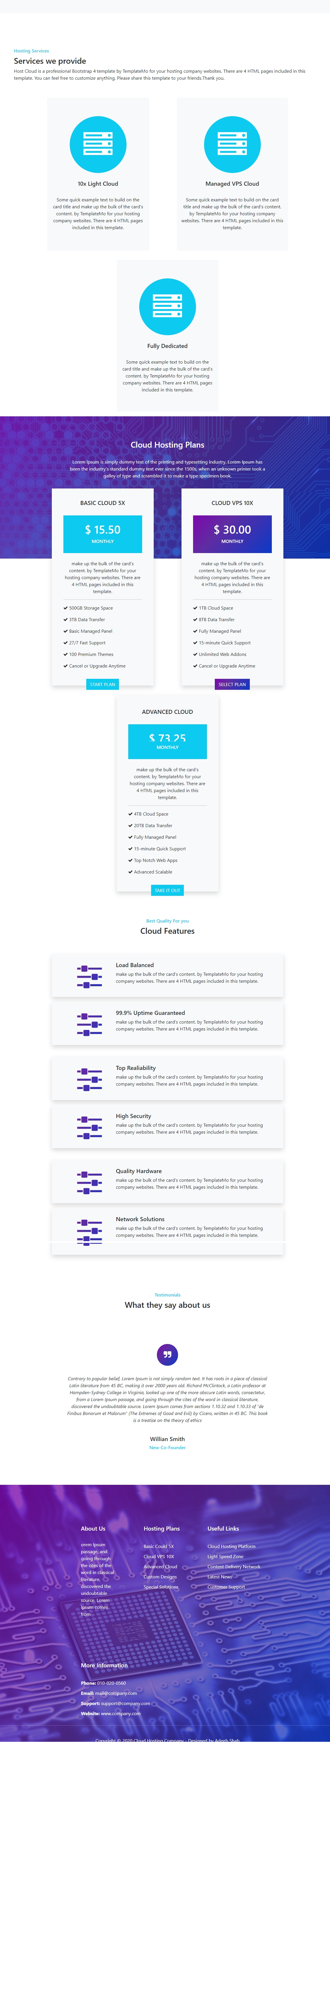

**Mobile ---**

